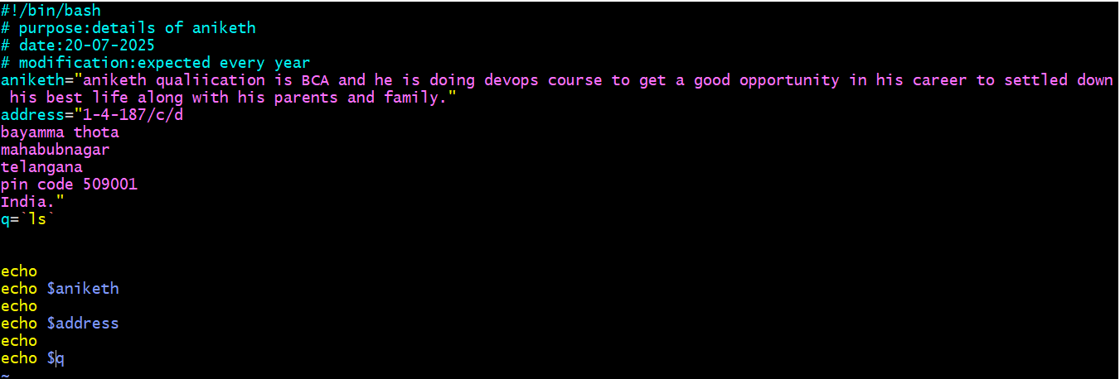

“ double quote has start and end and use to get print the matter provided in variable as above .

` back tick is use while writing a command in the variable as above

= is used after variable and should not give space after =

Without veriable also you can give direct commands in the script

After echo no need to keep back tick ` or double colon “ I you give back tick it won’t work but double colon can work.

And after variable equal no need to give “double colon If variable consisting of one word and if variable consisting of more than one word has to give “double colon at start and end. But or commands in variable have to give ` back tick at start and end

Example

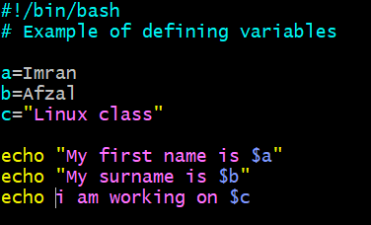

Scenario 2

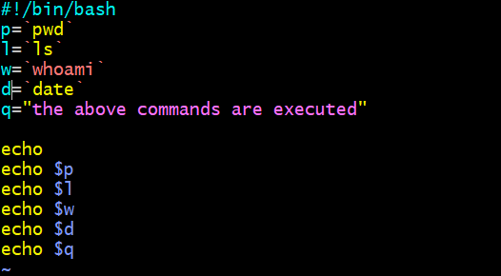

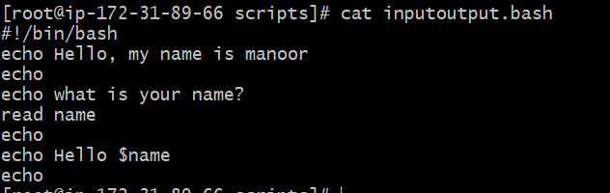

Ater excuting script ile

Here read --> To take command from user

echo --> to print the output

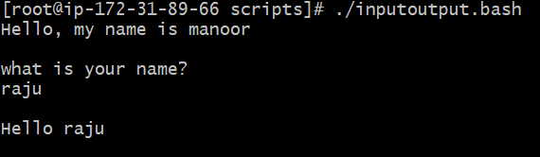

Bash scripting Task 3 from below